**Introduction**

With the steady increase in the financial data it’s essential that we have a precise, reliable & intelligent system which consolidates the data gathered from financial organizations. There exists various such standards where the data has been communicated across the systems such as ANSI X12, EDIFACT, SWIFT they all follow a specific file structure which comprises of the data appearing as per specifications. To process these files you would require to setup various B2B translators, setup maps to translate the data and other tools involving huge costs of setup and maintenance.

There arises a need for a tool which processes these files irrespective of the file format or the structure which would be an effective mode of communication and bearing a low cost of implementation.

Our application looks towards this need and provides a solution for the same. It is a learning application which takes the input as any file format without a predefined specification and it would learn and understand the structure by storing the data structure every time a new structure or a change arrives creating a repository of the file formats with its structures. This will reduce the failure of these files during the processing and reduce the time delays. The files will be processed as an implementation of Pattern learning, Fuzzy logic and Keyword search.

We have considered a sample file format of an Invoice in an XML Format for the purpose of the implementation. This can be useful to all the firms in representing its financial invoices on the same basis as its foreign competitors, making comparisons easier. Implementation of this system will give the liberty to all the financial bodies to setup & follow their own standards.

**Indexes**

* Below shown are the Indexes for the respective tables in the Database ‘dbteragigs’

**Table : address_mstr**

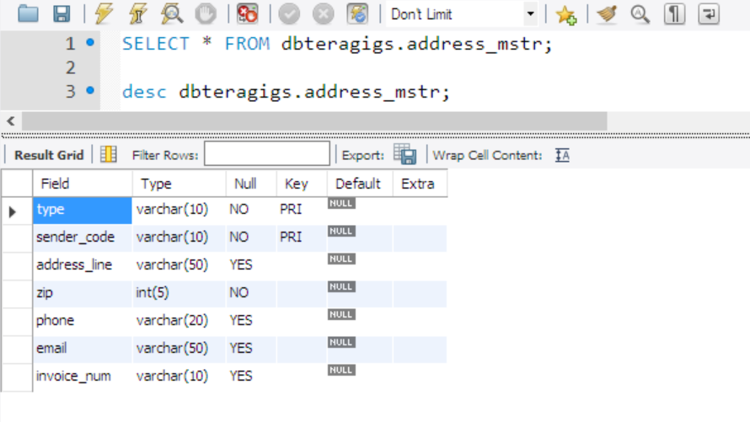

**Table : header_mstr**

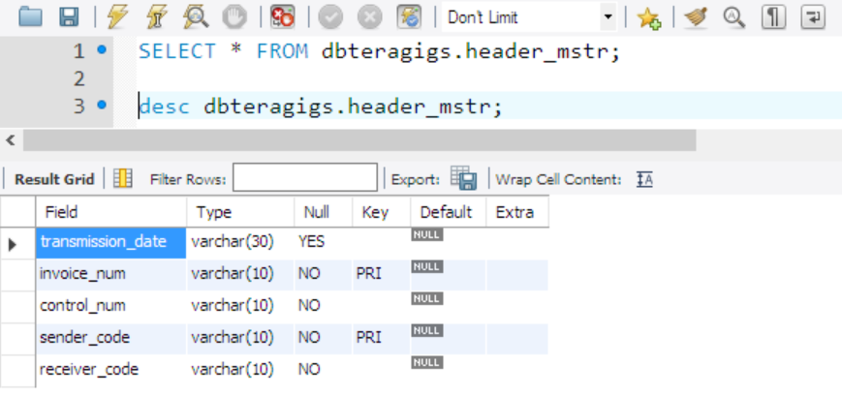

**Table : invoice_header**

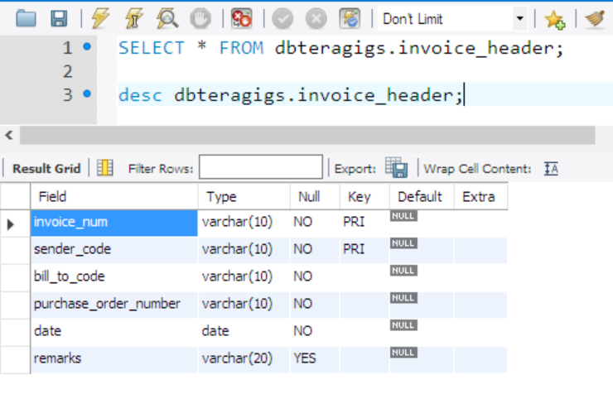

**Table : detail**

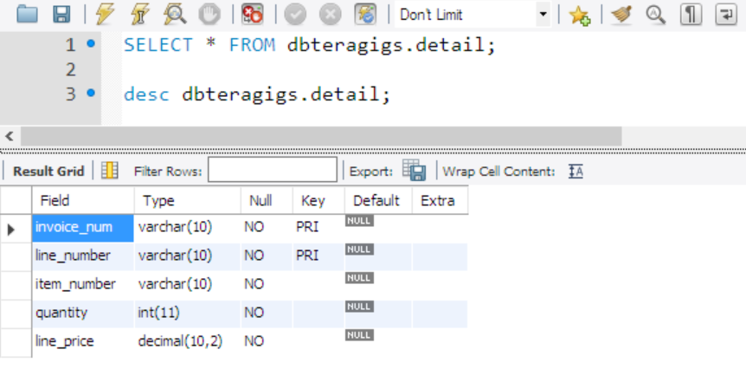

**Table : item_mstr**

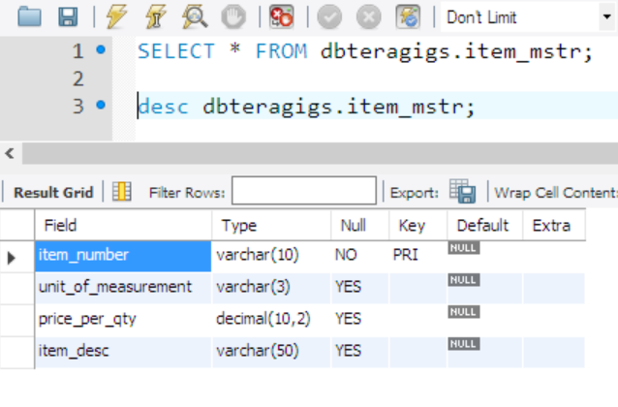

**Table : summary_mstr**

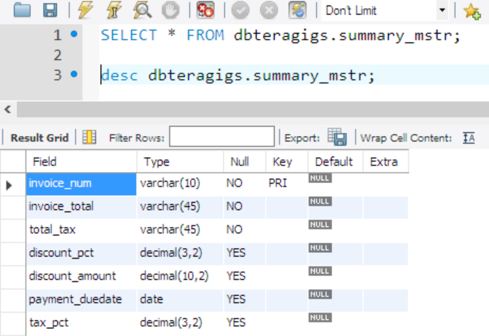

**Table : header_mstr**

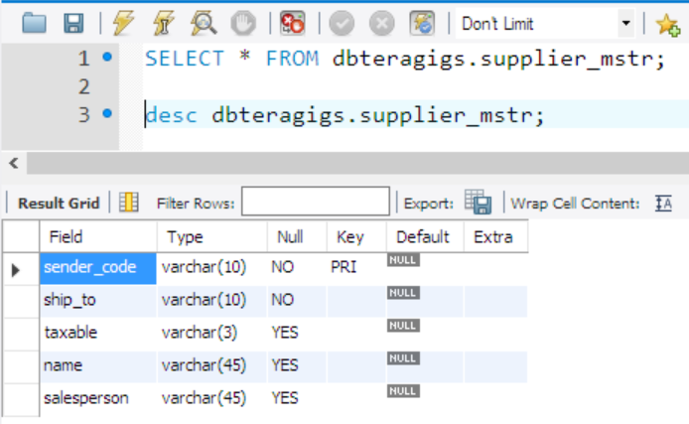

**Backup Plan**

* Considering the application involves processing of documents such as Invoices, Payments, Orders etc., critical information will be transmitted as well as processed and stored which will require timely backing up.
* Since the functionality of the application has transactional processing, it will require to be up and running for most part of the day thereby offering a very less down time which will provide a little time perform schedule full backup of the database.
* There will be two types of Backups involved for our application :

1. Incremental Backup
2. Full Backup

* The downtime will be available during the night and during this window an Incremental Backup will be scheduled for only the changes made beyond the last backup save points as the time availability will be less for a full backup
* As per the assumption that there will be 6 working days from Monday to Saturday and the time taken for a full backup will be around 8 hours to complete while the Incremental backup will take about 4 hours. Considering the time taken and time available, following will be the schedule for backup process :

**Backup Schedule :**

|  |  |  |
| --- | --- | --- |
| **Day of the Week** | **Backup** | **Schedule** |
| Monday | Incremental | 1:00 am to 5:00 am |
| Tuesday | Incremental | 1:00 am to 5:00 am |
| Wednesday | Incremental | 1:00 am to 5:00 am |
| Thursday | Incremental | 1:00 am to 5:00 am |
| Friday | Incremental | 1:00 am to 5:00 am |
| Saturday | Incremental | 1:00 am to 5:00 am |
| Sunday | Full Backup | 10:00 am to 6:00 pm |